**LINE FOLLOWER ROBO COMPETETION**

**RULES and REGULATION:**

1) Base for the track will be white in colour.

2) Track will be made in black colour, 3 cm wide.

3) Robot is to be placed at the start square (25cm*25cm).

4) Maximum permissible size of the robots is 20cm*20cm*20cm.

5) Robot has to be wireless. No wiring will be provided in order to supply power to Robot.

6) Replacement of battery during the competition is allowed (max 2 times).However, replacement of any hardware is not allowed during the competition.

7) Robot can be restart maximum 4 times during the competition. If still Robot is not able to reach the end point, Robot will be disqualified.

8) Time taken to complete the track by Robot will be noted. In case Robot fails to complete the track in given limit of time, distance covered by Robot will be evaluated.

9) If any team member touches the Robot, in any case except for the restart, team will be disqualified.

10) For every restart, penalty of 5 seconds will be applied.

11) In case of restart, Robot will start from current position i.e… Robot doesn’t need to begin from start square.

12) Each team will be comprising of Maximum 4 students. One student will be the Captain to represent the team.

13) Online registration is compulsory.

14) Selected teams from First round will participate in Second or Final round.

15) 10 minutes practice will be available on different track before the competition begins.

16) Maximum operating voltage of robot should not exceed 24V.

**SAMPLE TRACK**

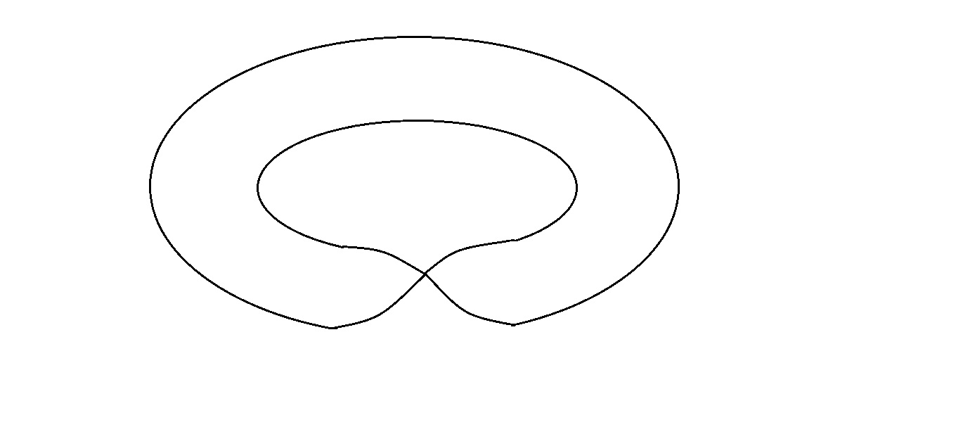

**NOTE:** This is only a sample track & will not be choosen for competition.

**For Any Queries, Contact:**

Apoorv: 9999965329

Hardik: 9811939537.

Samnit: 9013290517